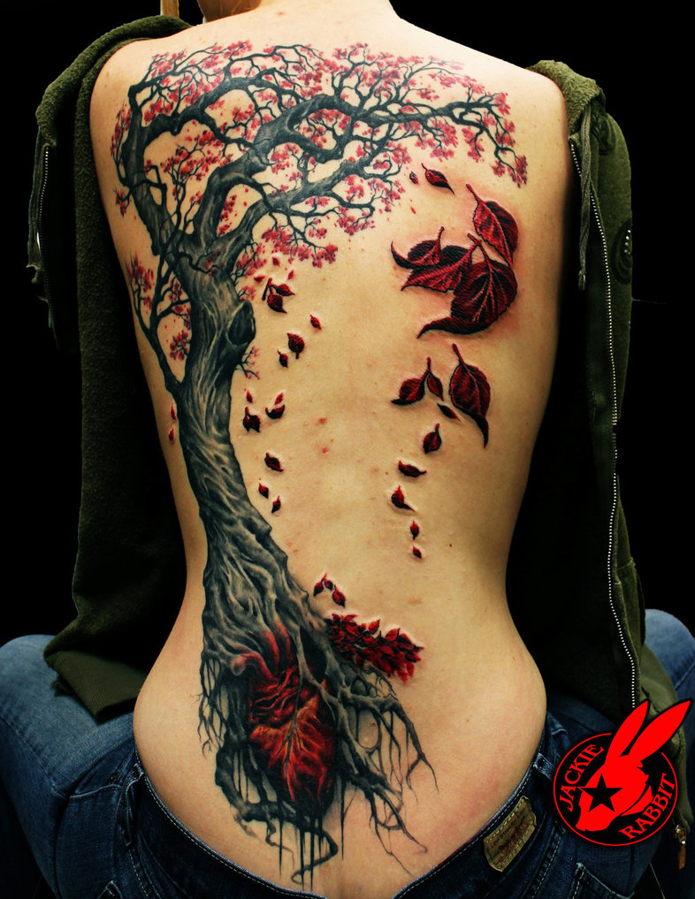

<http://jackierabbit12.deviantart.com/art/Heart-Tree-Tattoo-by-Jackie-Rabbit-435105270>

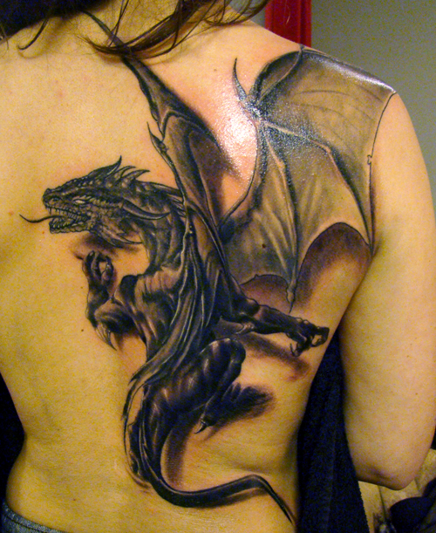

<http://jrunin.deviantart.com/art/dragon-tattoo-170824000>

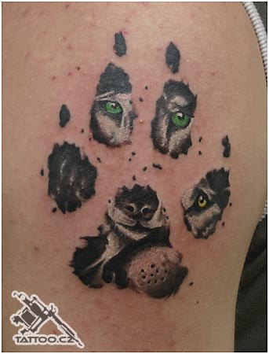

<http://robincz.deviantart.com/art/Wolf-footprint-tattoo-65447458>

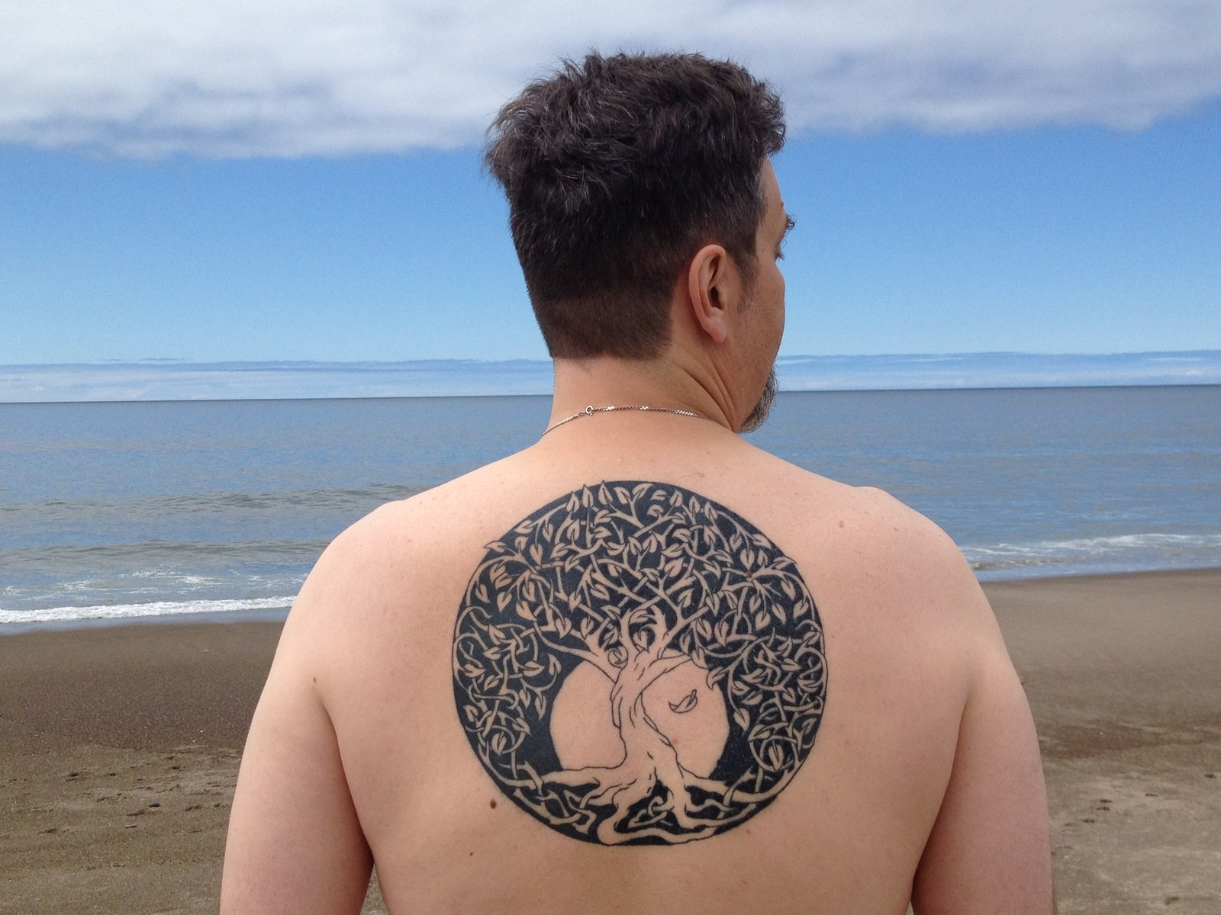

<http://tattoo-design.deviantart.com/art/Celtic-tree-of-life-Tattoo-318081264>



<http://meatshop-tattoo.deviantart.com/art/The-Dancing-Lord-Shiva-tattoo-463476179>

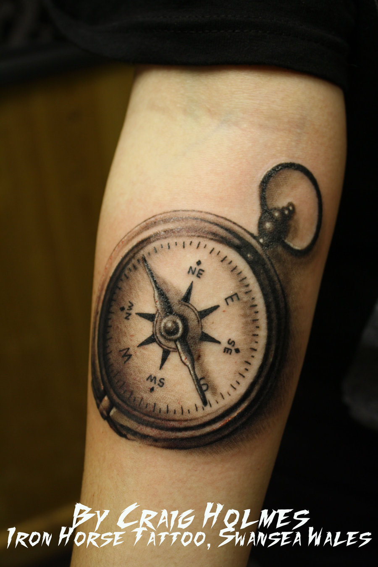

<http://craigholmestattoo.deviantart.com/art/Compass-tattoo-203723024>

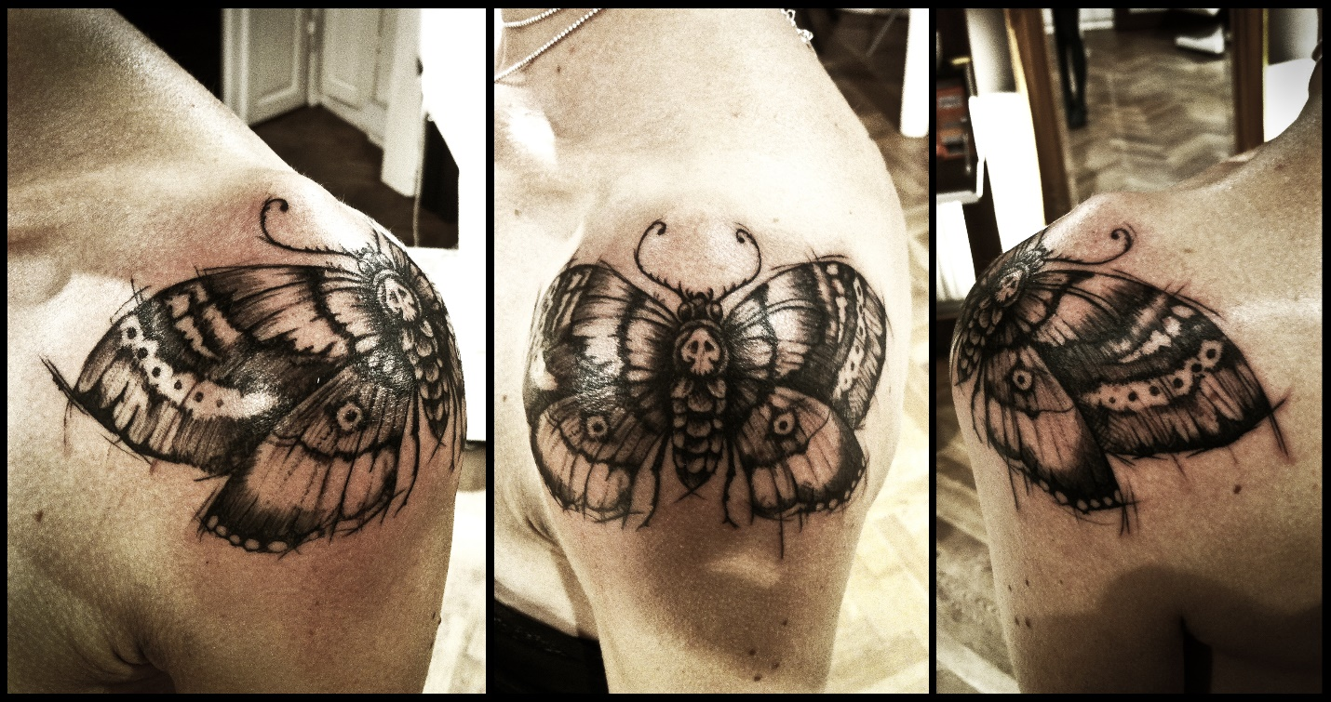

<http://meatshop-tattoo.deviantart.com/art/Deathhead-moth-tattoo-373292698>

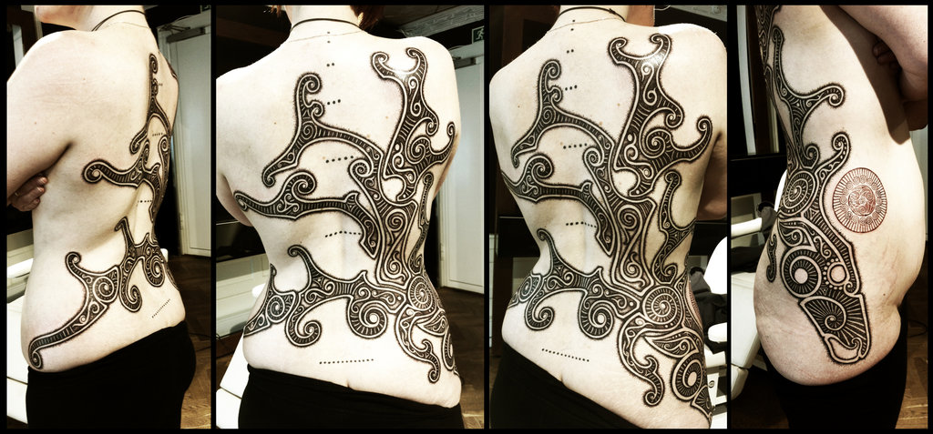

<http://meatshop-tattoo.deviantart.com/art/Stag-of-the-sun-tattoo-370272369>

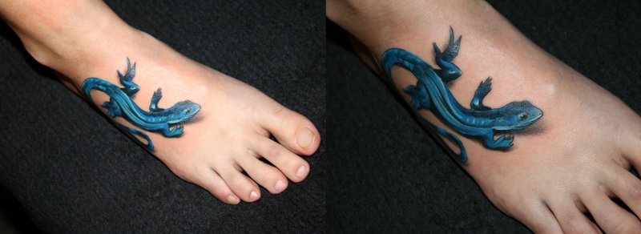

<http://2face-tattoo.deviantart.com/art/Blue-gecko-Tattoo-106527345>

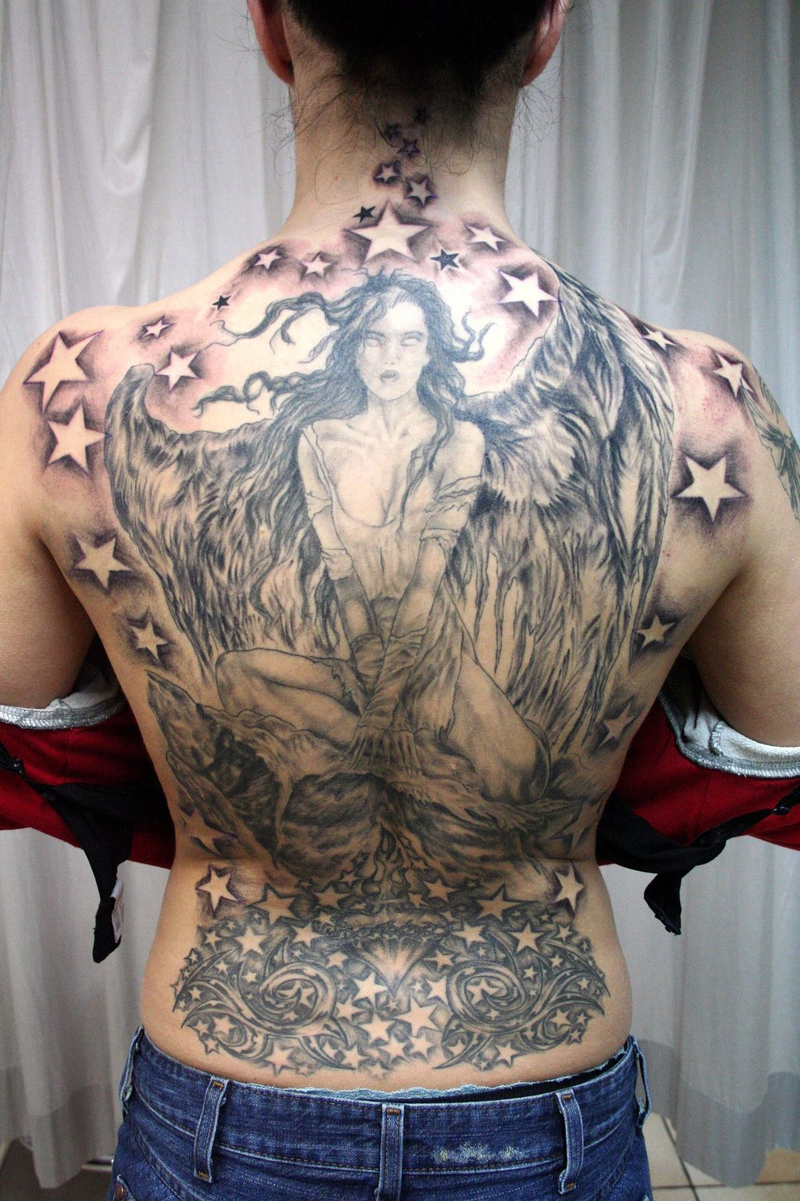

http://2face-tattoo.deviantart.com/art/Angel-Wings-finished-Tattoo-76365706